Section10:bash scripting

1.setting up vms

-create 3 vms in the vagrantfile

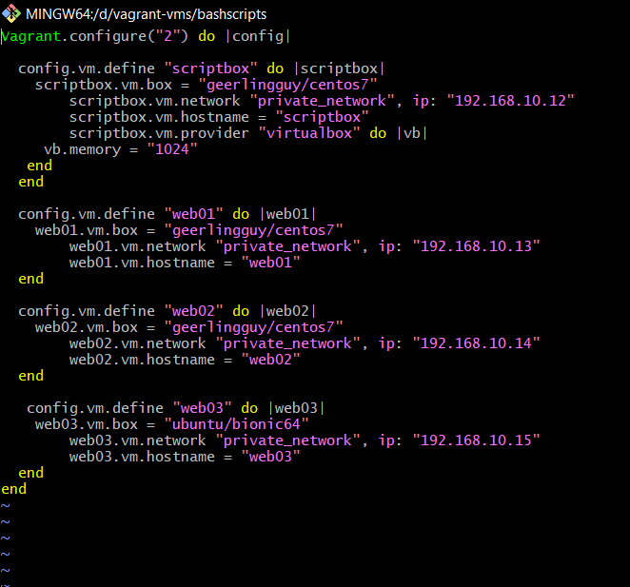

-loading only the scriptbox vm for now

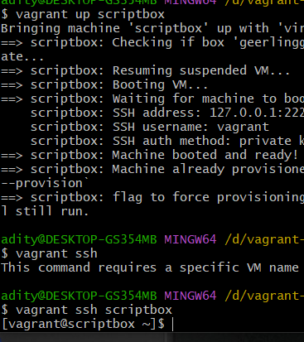

-changing the hostname of scriptbox vm

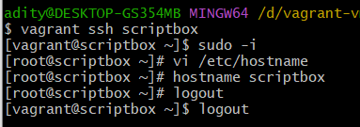

-creating the first bash script



-first script

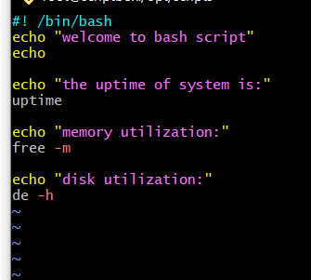

-runnning script the permission is denied u need to change the permission

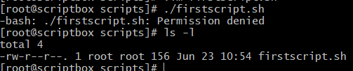

-make the script more readable

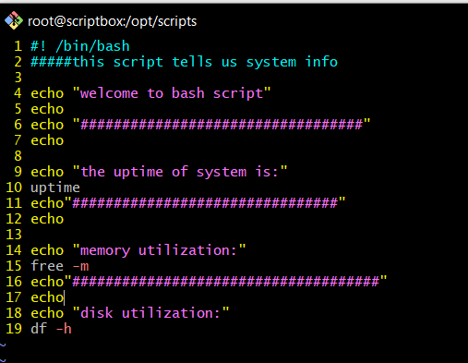

-output

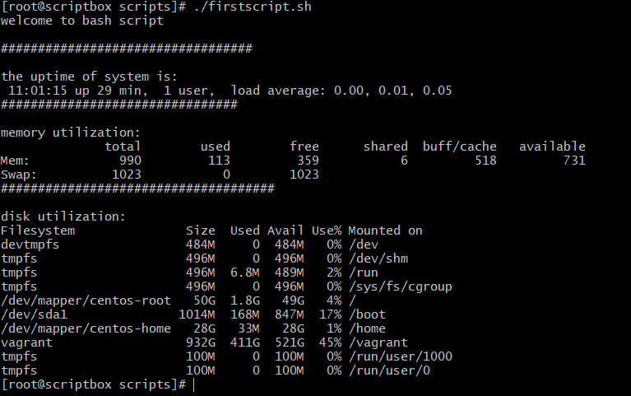

2.sample script for web template

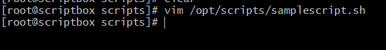

-enter this

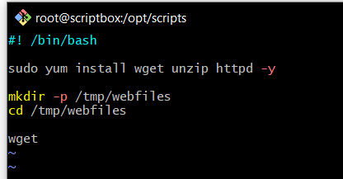

-copy

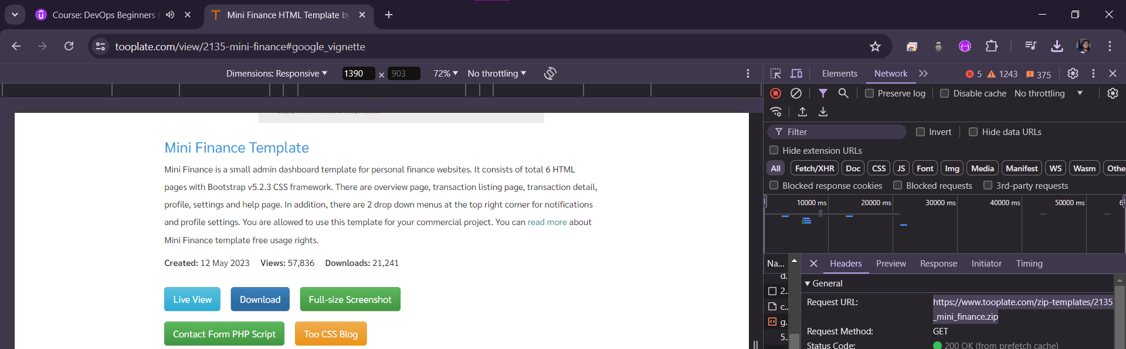

-content of the file

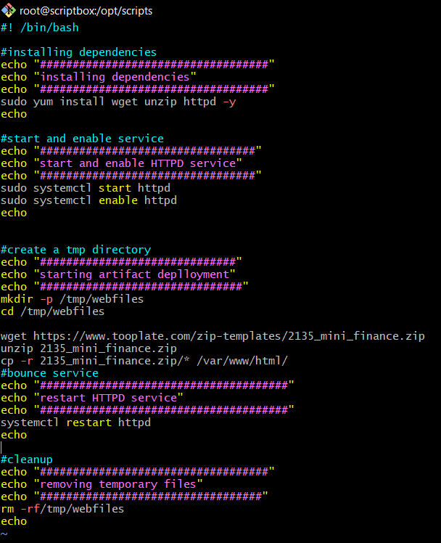

-chaning the usr and executing the script

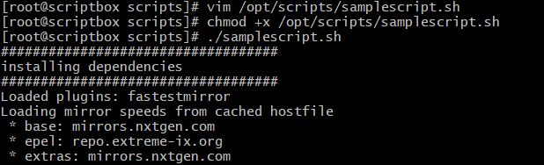

-running the user with all the scripts

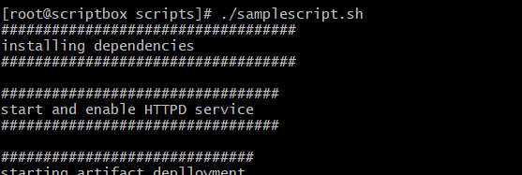

-updated file

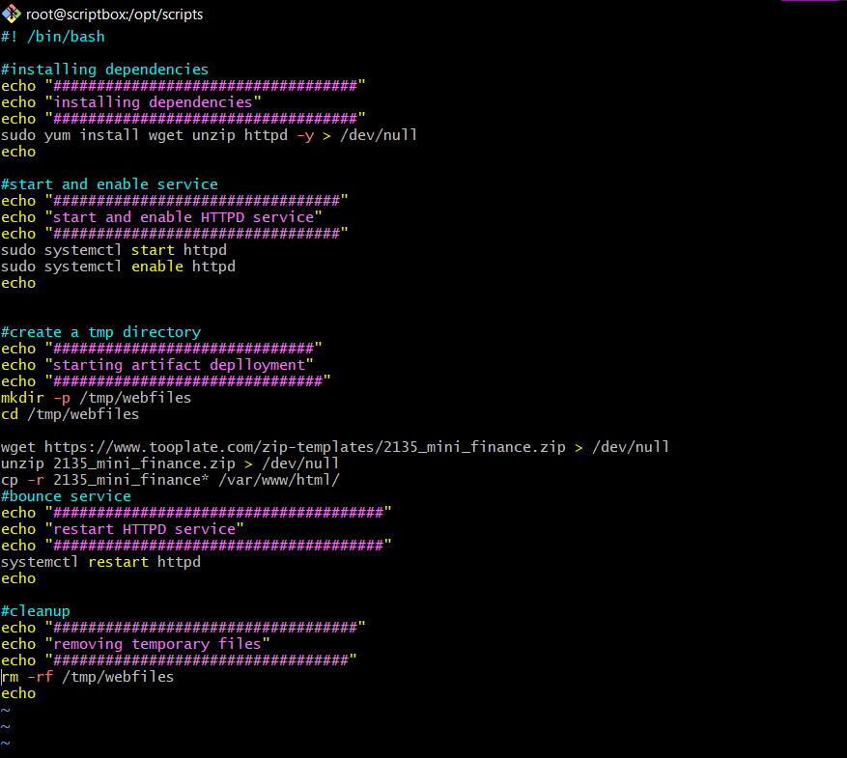

-copy ip and paste on web

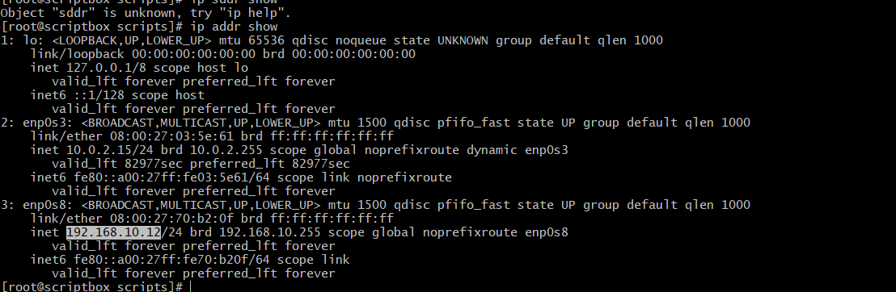



3.variables

-declaring a variable



-to see the output we nee dto put a $ sign



-install the packages thru variables

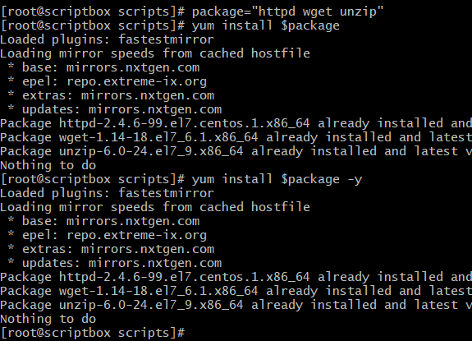

-renaming

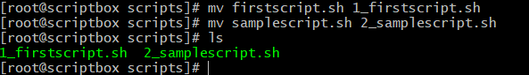

-add lines 3 to8

And make the more suitable changes

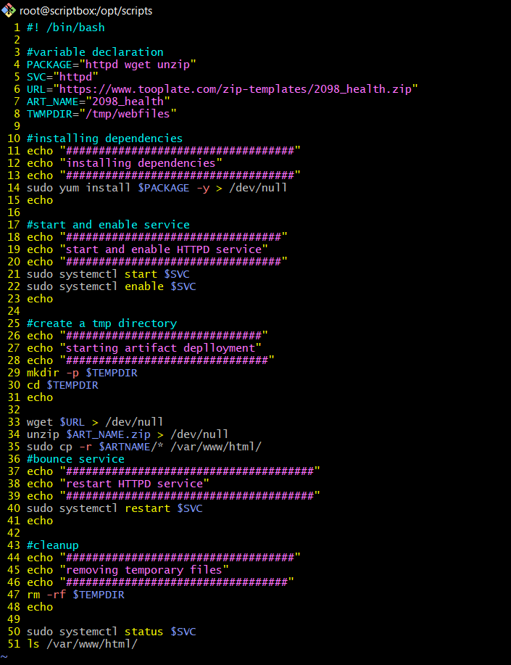

-output



4.command args

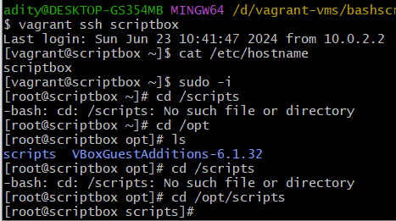

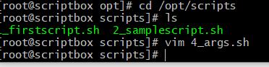

-add this

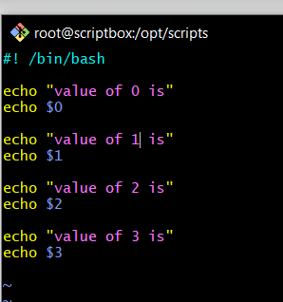

-make the script executable



-example of the variable

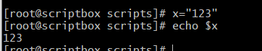

well u can see op of 0 is file name but others have no op cause we didint pass any args

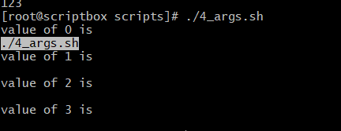

-here we have passed the args

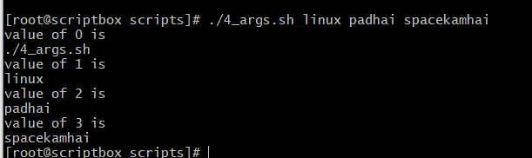

-copy and createa new file

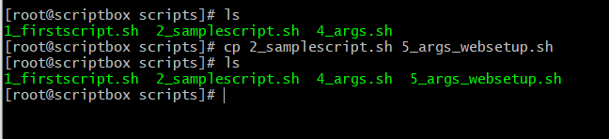

-copy the file and comment the highlighted

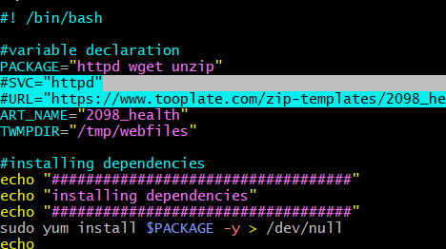

-make the changes here

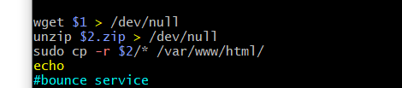

-copy and paste this template

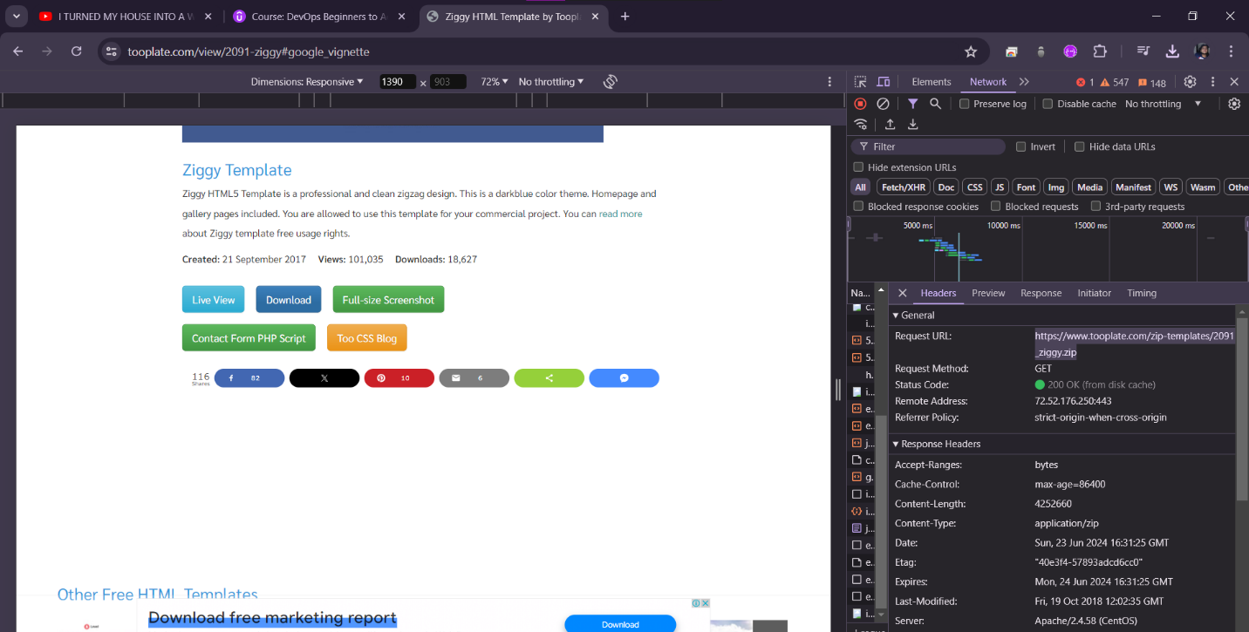

-now we have made the script as a reusable script

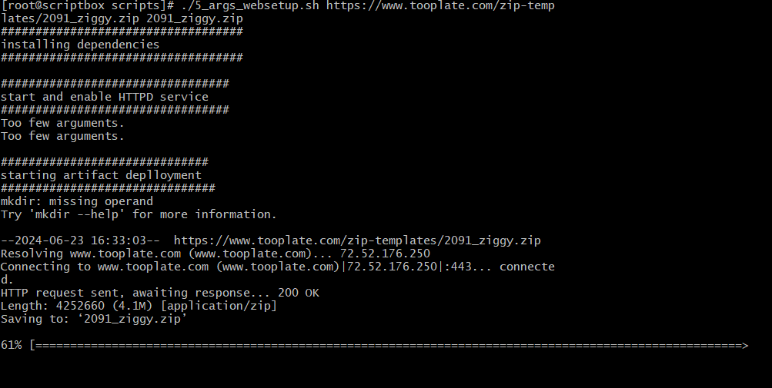

5.system variables

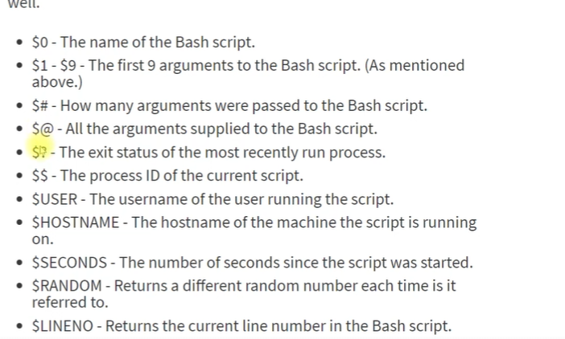

-1.echo question mark 1 is failure of last cmd and 0 is success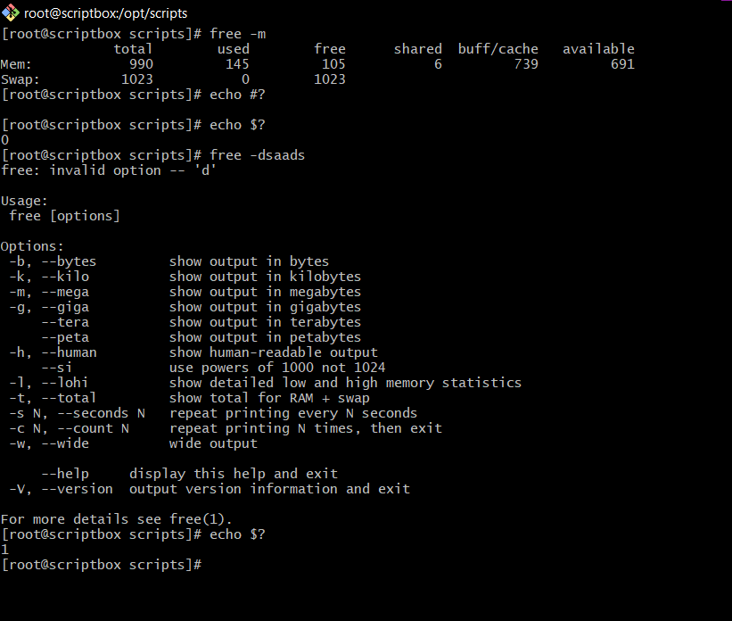

-other cmds

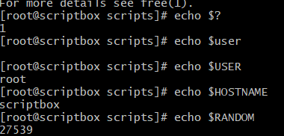

6.quotes

